HOME PAGE
Below are the key issues and required improvements:
Top Deals on homepage
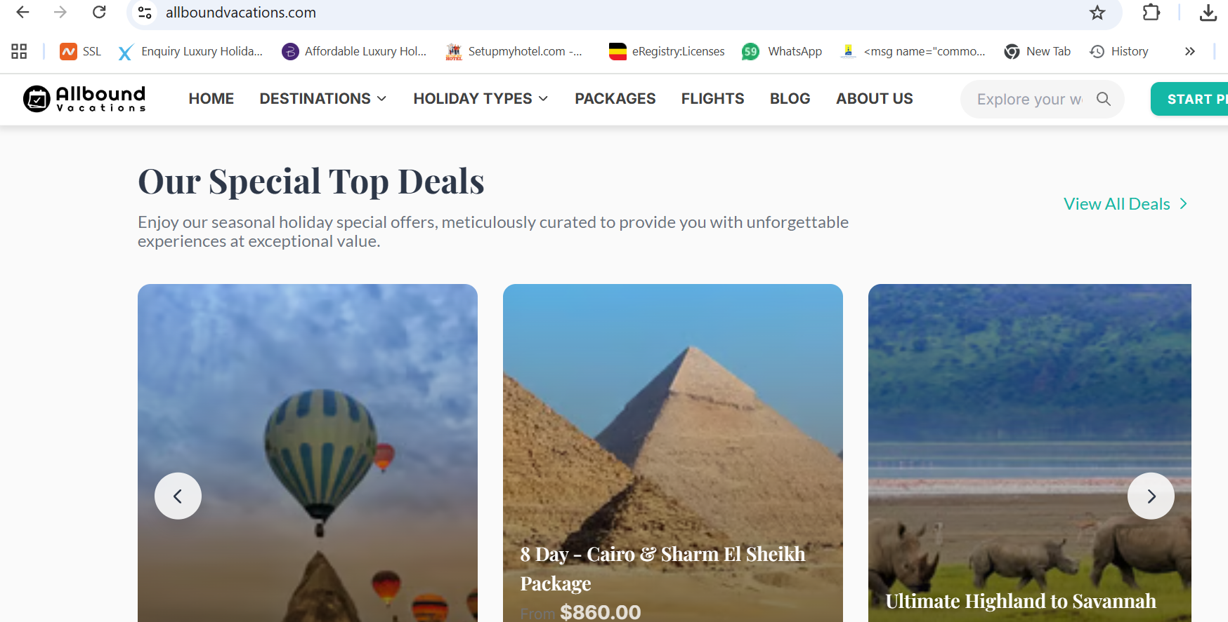
Can you find out why images on this section are not very clear
Is there a way we can add these (flights+hotel+car+activity) icon same as the below:
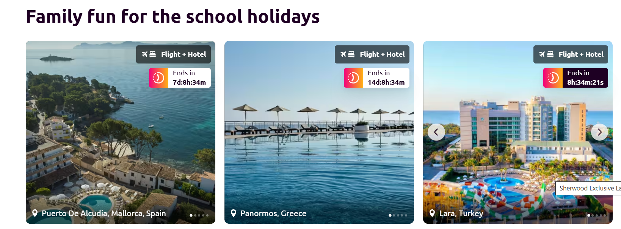

Background Colour
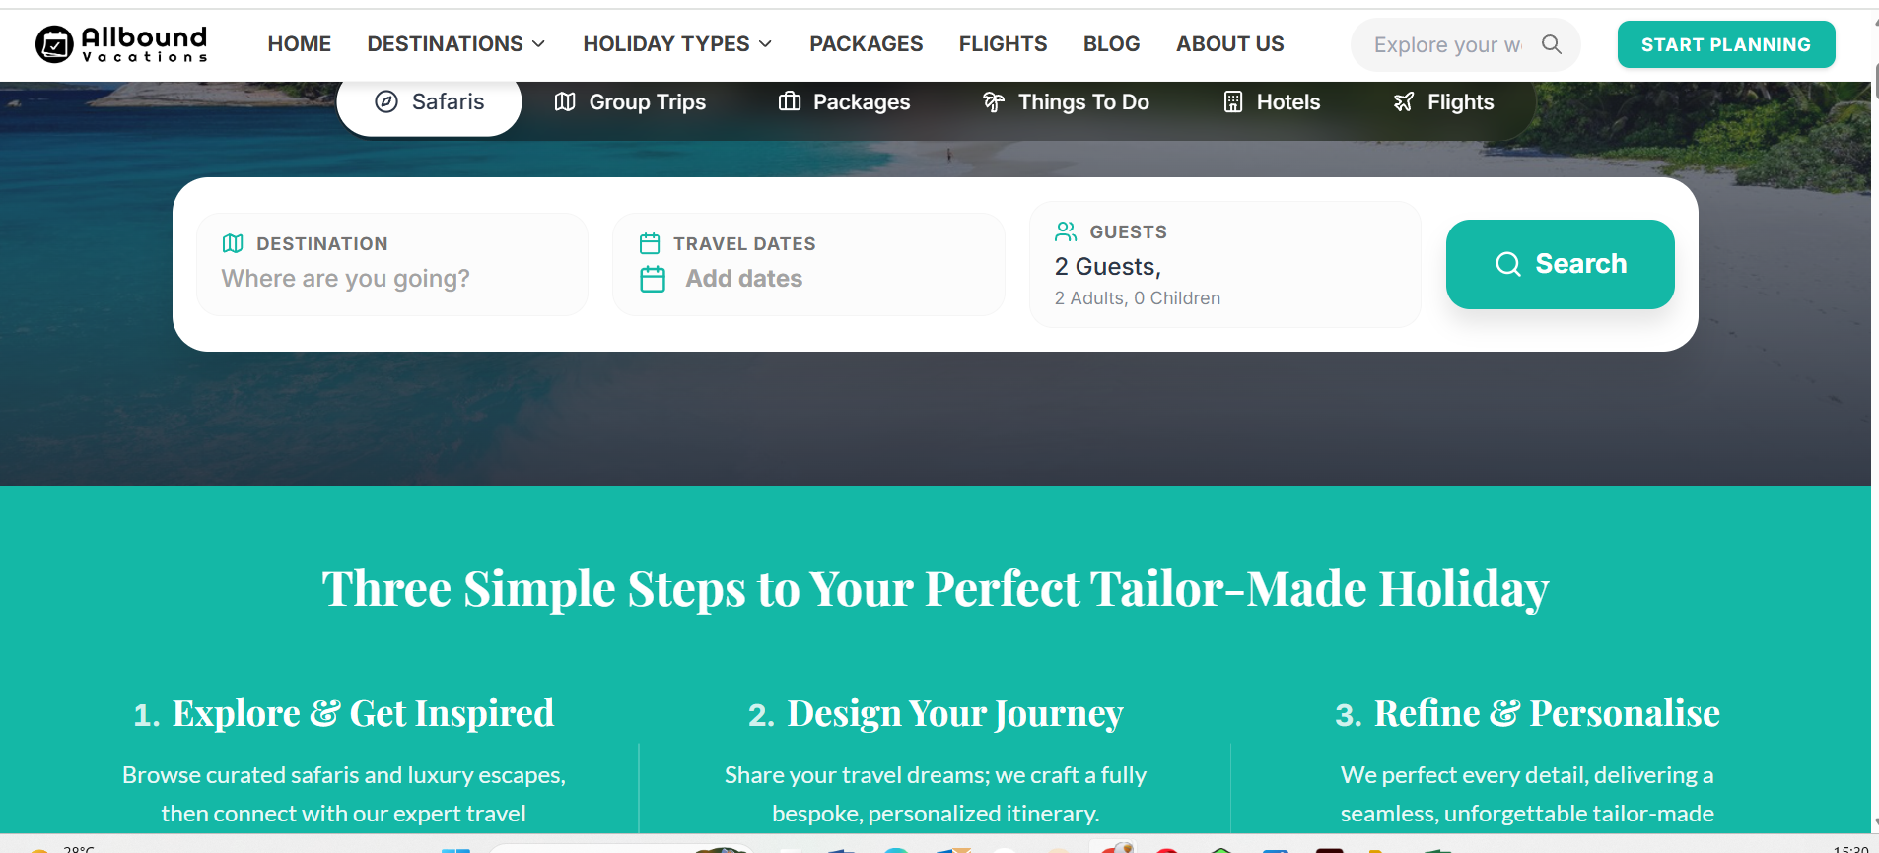
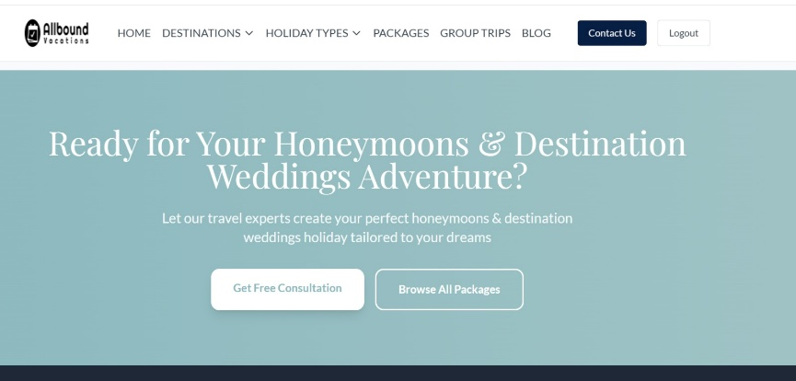
The green colour appearing on backgrounds, buttons and texts should be this 8fbac0
it’s subtler and welcoming.

Request a quote button: c4a9af

Hotel Pages – Images Not Displaying
- Some hotel images are currently not showing.
- This needs urgent fixing as visuals are critical for user experience and conversions.
- Hotel page gallery to have this design

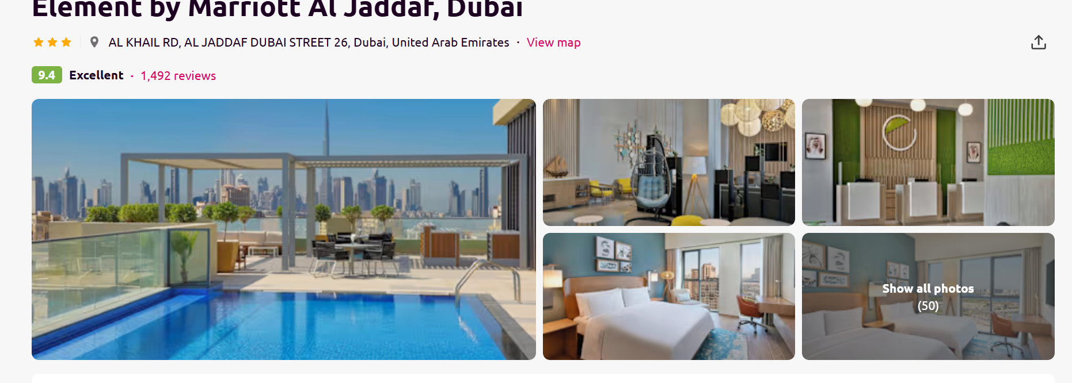
Menu Glitch (Shaking on Scroll)
- The navigation menu behaves abnormally when scrolling (shaking/jittering).
- This affects usability and needs to be stabilized.
Full-Width Layout
- Pages should utilize full-width layout for a more modern, premium look and better content display.
“Why Visit Destination” Section
- This should be dynamic/editable from the admin side so content can be updated easily based on marketing focus or destination priority.
Top Experiences Section
- Currently, text is embedded on images and not clearly visible, making it look cluttered.
- We need proper text overlays or separate text sections for clarity and responsiveness.
Group Trips (Admin Issue)
- The Group Trips function in the admin panel is not working.
- I’m unable to add or manage content, this needs to be fixed so we can upload and sell group packages.
- Also add it to top menu items
Destination Page ( eg Uganda)
Content flow>>>
- Uganda Overview
- Why Visit Uganda – dynamic content
- Best time to visit
- Top Things to Do
- Travel Experiences
- Featured Uganda Packages
- Uganda Travel Deals
- Accommodation
- Uganda Travel Guide – new
- Travel Tips & FAQs
- Blog
- Simimar Destination Destinations
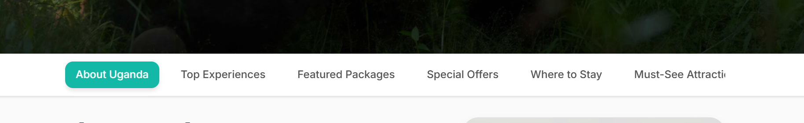
How dow we make sure that these menu items are visible on same screen?
Cane we have 2 lines ?
Destination Sub-Navigation Bar
Should be displayed consistently across all destination-related pages that open independently after load more button, including:
    - Top Experiences
    - Featured Packages
    - Special Offers
    - Where to Stay
    - Must-See Attractions
    - Group Trips
Sample : https://www.scottdunn.com/uganda
This navigation bar must repeat on each individual page within the destination section to ensure seamless user experience and easy movement between sections.
Page Descriptions
Kindly assist in updating the Destination Sub-Navigation pages to include a dedicated section/area for descriptions on each individual page. This applies to all pages that open independently after clicking the “Load More” button, including:
  - Top Experiences
  - Featured Packages
  - Special Offers
  - Where to Stay
  - Must-See Attractions
  - Group Trips
Adding description fields on these pages will allow us to input SEO-friendly content, improving search visibility and providing better context for users.

Best Time to visit :
Kindly update the “Best Time to Visit” month section as follows:
- Reduce Box Size
  - Please reduce the width and height of each month card to approximately 50% of the current size.
  - The goal is to make the section more compact and less bulky.
- Layout Adjustment
  - Arrange all 12 months in a single horizontal row if possible.
  - If screen width does not allow, limit it to a maximum of 2 rows (not 3 as it is currently).
- Responsive Behavior
  - On desktop: Aim for 1 row (scrollable if needed) or 2 rows max.
  - On tablet/mobile: Ensure clean stacking (2 rows or swipe/scroll).
The overall goal is a cleaner, more compact, and modern layout with improved user experience.
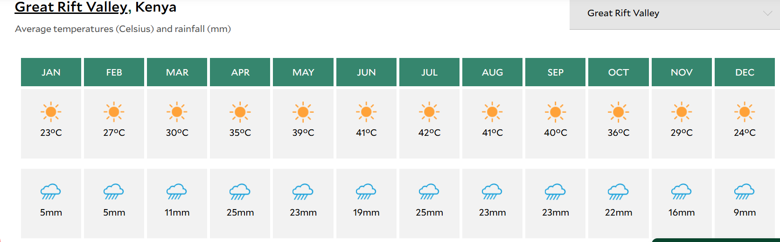
https://www.scottdunn.com/kenya/best-time-to-visit

Travel Guide for Destinations:
I’d like the Travel Tips section on the destination pages to follow the same layout and structure as the below example , should appear after accommodation
Use categories like:
- Good to Know
- Things to Do
- Going Out
- Shopping
- Beaches
- Food & Drink
- Sports
- Events
- 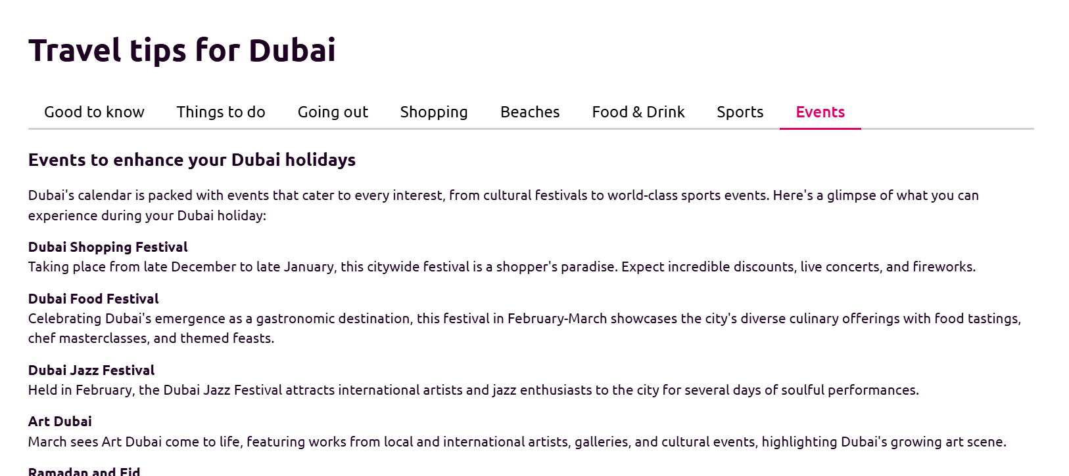
- https://www.lastminute.com/holidays/ae_united-arab-emirates/dubai-d1004157094

Page Filters
Destination page filter system
These appear on the left of every destination page as Vincent’s

🔎 Primary Filters (Tabs Style)
- ✈️ All Experiences
- 🏨 Hotels
- 🧳 Packages
- 🎯 Activities
- 📍 Attractions

Hotel Page Filters (Accommodation listing Page)

Accommodation Filters
- Star Rating (1★ – 5★ Luxury)
- Property Type:
  - Hotel
  - Resort
  - Apartment
  - Boutique Hotel
  - Safari Lodge
- Meal Plan:
  - Room Only
  - Bed & Breakfast
  - Half Board
  - Full Board
  - All Inclusive
- Budget Range:
  - Economy
  - Mid-range
  - Luxury
  - Ultra Luxury

Package Filters (Package listing Page)
- Destination
- Package Type:
  - African Safaris
  - Beach Holidays
  - Family Holidays
  - Honeymoons
  - Luxury Holidays
- Budget Range

- Duration:
  - 2–3 Days
  - 4–6 Days
  - 7–10 Days
  - 10+ Days
- Travel Style:
  - Group Tours
  - Private Tours
  - Luxury Packages
  - Honeymoon Packages
  - Family Packages
  - Budget Deals

Activities Filters (Activity listing Page)
- Activity Type:
  - Adventure
  - Cultural
  - Nature & Wildlife
  - Water Sports
  - City Tours
  - Food & Culinary
  - Nightlife
- Intensity Level:
  - Relaxed
  - Moderate
  - Extreme
- Duration:
  - Half Day
  - Full Day
  - Multi-Day
- Suitability:
  - Couples
  - Families
  - Solo Travelers
  - Groups
- Popularity:
  - Top Rated
  - Most Booked
  - New Experiences

Attractions Filters (Attraction listing Page)
- Attraction Type:
  - Historical Sites
  - Museums
  - Natural Wonders
  - Religious Sites
  - Theme Parks
  - Landmarks
- Visit Duration:
  - Quick Stop (1–2 hrs)
  - Half Day
  - Full Day Experience

Quick Filters (Buttons)
- Top Rated
- Most Popular
- Best Value
- New Listings
- Recommended for You

🧠 Personalization Filters
- Couples
- Solo Travelers
- Families
- Corporate Groups
- Luxury Travelers
- Budget Travelers

Start Planning

https://www.timbuktutravel.com/enquire/step/1

Multi-Destination Trip Setup

We need to update the backend to support multi-destination trips. Some trips are not limited to one country. We must be able to create a single trip that includes multiple destinations, for example:
- Kenya & Tanzania
- Kenya, Tanzania & Zanzibar

Our Partners & Affiliations
Under this section, display three sub-sections:

Hotel Partners
- List or logo grid of hotel partners

Airline Partners
- List or logo grid of airline partners

Industry Affiliations
- Travel associations, tourism boards, certifications, etc.

Packages landing Page
We need to add a text introduction section on the Packages Landing Page to improve SEO and overall page presentation.
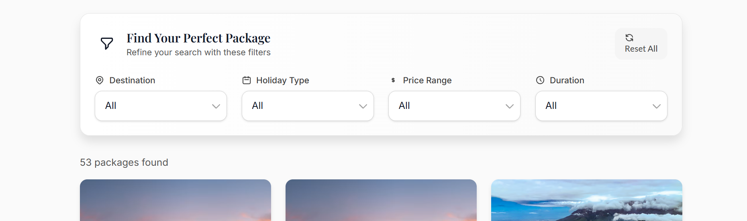
This section should:
- Improve search engine visibility (SEO)
- Provide a short introduction to travel packages
- Make the page feel more complete and professional
Affiliate program
  - Please see separate document
SEO & Revenue Focus
- We need to optimize the site for strong search engine visibility (SEO) so we can attract organic traffic and generate bookings.
- This includes proper page indexing, meta tags, keywords, fast loading speeds, and mobile optimization.
- The goal is to make the site rank well for travel-related searches and convert visitors into inquiries/bookings.

